

MUMBAI EDUCATIONAL TRUST
MET INSTITUTE OF COMPUTER SCIENCE

Program Number | 02
Roll Number | 1550
Title of program | 1)perform advance operation such insert ,update,delete mongoDB  2)Aggeration function in MongoDB
Objective | 1)perform advance operation such insert ,update,delete mongoDB  2)Aggeration function in MongoDB

Section A-CRUD Operations
> use ProductsDB1
switched to db ProductsDB1
> show databases
EmpDB 0.000GB
RetailDB 0.000GB
SalesDB 0.000GB
StudentDB 0.000GB
TeachersDB1 0.000GB
admin 0.000GB
config 0.000GB
local 0.000GB
> db.products.insert(
... {
... "_id":101,"name":"T-shirt"
... }
... );
WriteResult({ "nInserted" : 1 })
> db.products.insert(
... {
... "_id":102,"name":"T-shirt","brand":"AS","price":2300,"rating":3.9,"qty":23
... }
... );
WriteResult({ "nInserted" : 1 })
> db.products.insert( { "_id":103,"name":"jeans","brand":"AS","price":2500,"rating":4.5,"qty":20 } );
WriteResult({ "nInserted" : 1 })
> db.products.insert( { "_id":104,"name":"jeans","brand":"LP","price":2000,"rating":4.7,"qty":21 } );
WriteResult({ "nInserted" : 1 })
> db.products.insert( { "_id":105,"name":"shirt","brand":"VP","price":2800,"rating":3.5,"qty":27 } );
WriteResult({ "nInserted" : 1 })
> db.products.insert( { "_id":106,"name":"shirt","brand":"AS","price":2900,"rating":3.6,"qty":29 } );
WriteResult({ "nInserted" : 1 })
> db.products.insert( { "_id":107,"name":"jeans","brand":"VP","price":2800,"rating":3.6,"qty":26 } );
WriteResult({ "nInserted" : 1 })
> db.products.insert( { "_id":108,"name":"T-shirt","brand":"LP","price":2400,"rating":4.6,"qty":28 } );
WriteResult({ "nInserted" : 1 })
> db.products.insert( { "_id":109,"name":"T-shirt","brand":"VP","price":2480,"rating":2.6,"qty":24 } );
WriteResult({ "nInserted" : 1 })
> db.products.insert( { "_id":110,"name":"kurti","brand":"libasa","price":2880,"rating":4.3,"qty":29 } );
WriteResult({ "nInserted" : 1 })
> db.products.insert( { "_id":111,"name":"kurti","brand":"savana","price":2000,"rating":4.5,"qty":21 } );
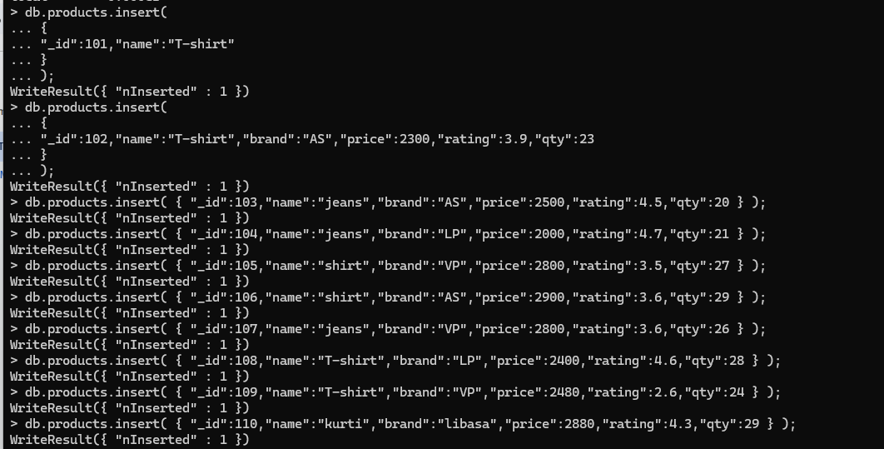
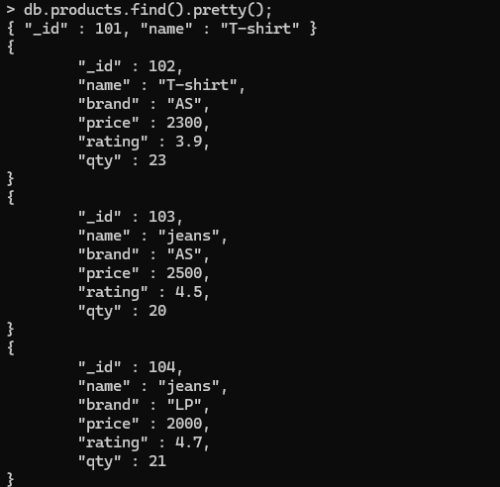

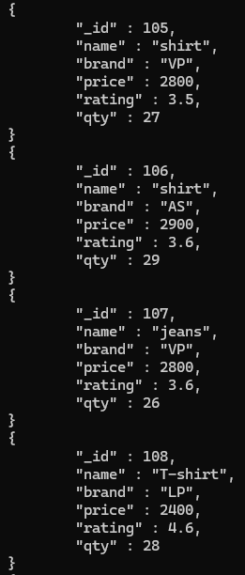

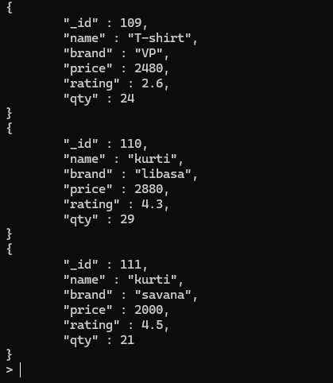

Update 1 document

> db.products.updateOne(
... {
... "_id":101
... },
... {
... $set:{"price":2800,"qty":21}
... }
... );
{ "acknowledged" : true, "matchedCount" : 1, "modifiedCount" : 1 }
> db.products.updateOne( { "_id":101 }, { $set:{"brand":"savana","rating":4.5} } );
{ "acknowledged" : true, "matchedCount" : 1, "modifiedCount" : 1 }

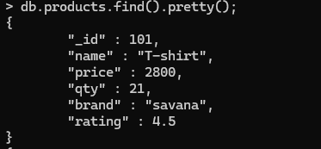

UPSET Document in mongodb
If the document exit update it otherwise insert a new document with specified key

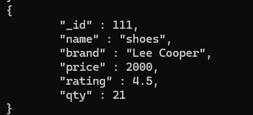
Write a Query to update the rating by .5 by all the record

> db.products.updateMany(
... {
... },{
... $inc:{rating:0.5}
... }
... );
{ "acknowledged" : true, "matchedCount" : 11, "modifiedCount" : 11 }
>

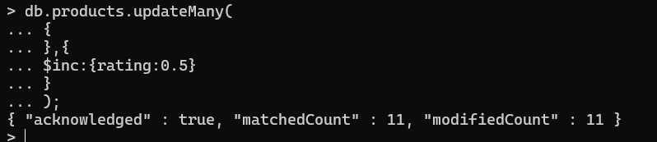

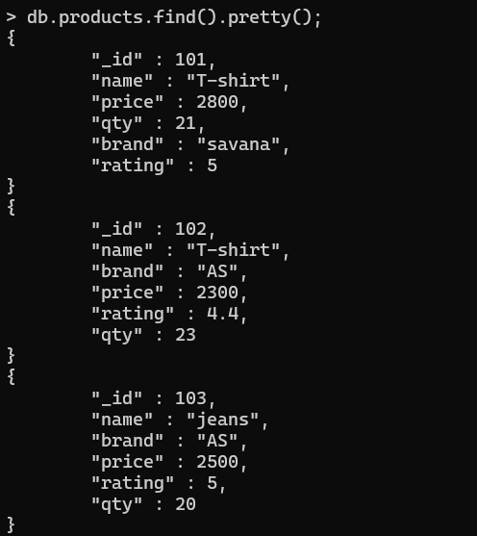

Write a Query to DaleteOne-
Purpose: Deletes the first matching document.
2nd record is deleted

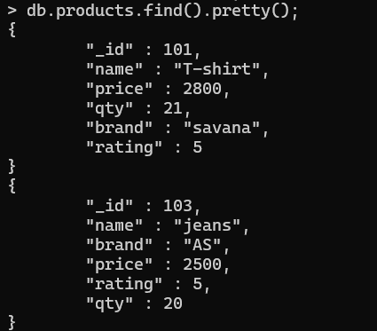
Delete using remove
Purpose–Deletes all matching documents.
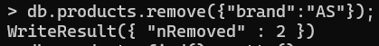
Record 3 and 6 are removed
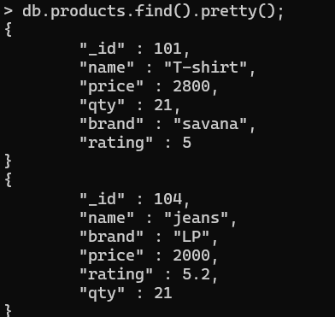

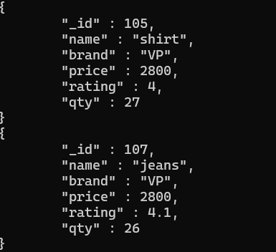

If no criteria is specified all the documents are deleted

Section B-Aggregation in MongoDB
Aggregate function
Write a query to find the count of all the products according to their name
> db.products.aggregate(
... {
... $group:{"_id":"$name","count":{$sum:1}}
... }
... );
{ "_id" : "shoes", "count" : 1 }
{ "_id" : "shirt", "count" : 1 }
{ "_id" : "jeans", "count" : 2 }
{ "_id" : "kurti", "count" : 1 }
{ "_id" : "T-shirt", "count" : 3 }

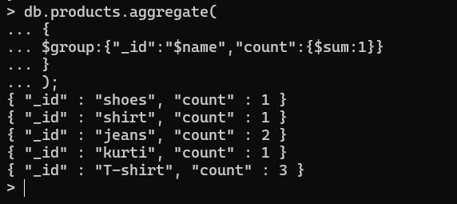

Create a query on the basic on name and show along with avg rating of each product category
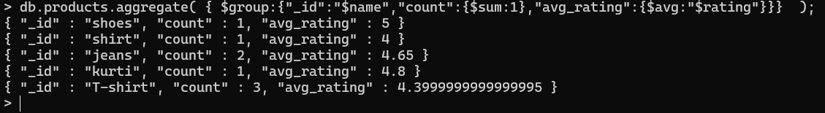

Write a query to find quantity according to brand
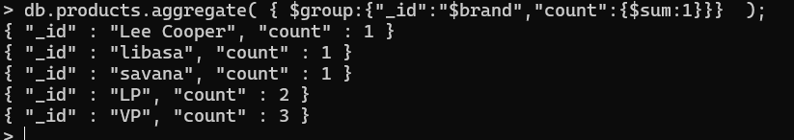

Find minimum and maximum price in each brand
